Software Development Unit 3, 3.3

Anna Legaspi

# I can setup and use access rights to enable others to access information

I’ve had Google Drive for over a decade and been using it vigilantly all this time. It is what I use to back up all my personal, education and important files. When I registered with Google Drive years ago, I was presented with Terms and Conditions or Terms of Service that I needed to agree with before I can access the service. I believe that the terms have been updated a few times since, but the most recent one can be accessed [here](https://support.google.com/drive/answer/2450387?hl=en-GB).

I will demonstrate that I can enable others to access data I wish to share using Google Drive. I will also demonstrate that I am choosing which data I want to share and only sharing this unit’s coursework. I also get to choose who I’m sharing It with and in this instance, it will be to my tutor, Shafiq.

I have a lot of personal information in my Google Drive and I need to ensure that this isn’t shared online. If I end up sharing my personal information to others such as my email address, I could end up getting spammed with unwanted emails. Even worse, they might access my scanned passport photo and have a risk of being the victim of identity fraud!

## Demonstration

I’ve accessed my Google drive online and went to the folder where this course, Unit 3 is. On the right of the page, I can see who can access this folder and the ability to Manage access (as highlighted).

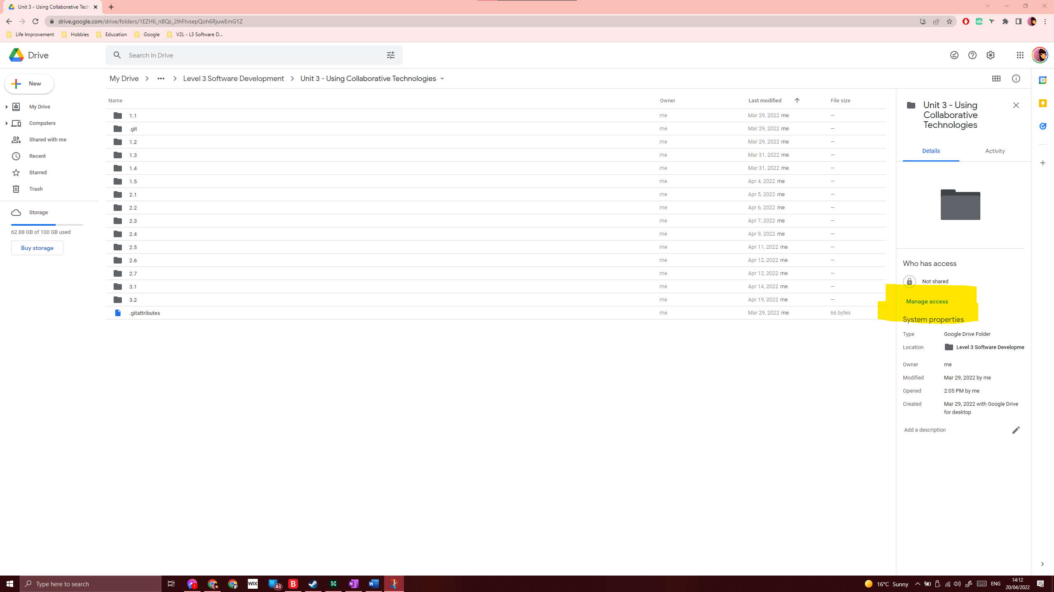

When I select ‘Manage access’, I’m presented with a pop-up that gives me two options. To ‘Share with people and groups’ or to anyone with link. In this example, I only want my tutor, Shafiq, to access my files.

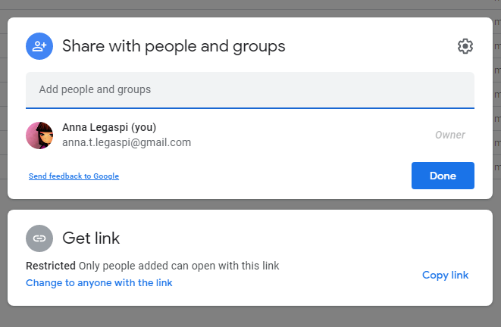

I then add my tutors email address, and decide what type of access I’d like to grant him. In this example, I am going to allow him read-only access, which means he can view, but not edit, amend or comment. I’ve also ticked ‘Notify people’ so my tutor is prompted by the grant of access.

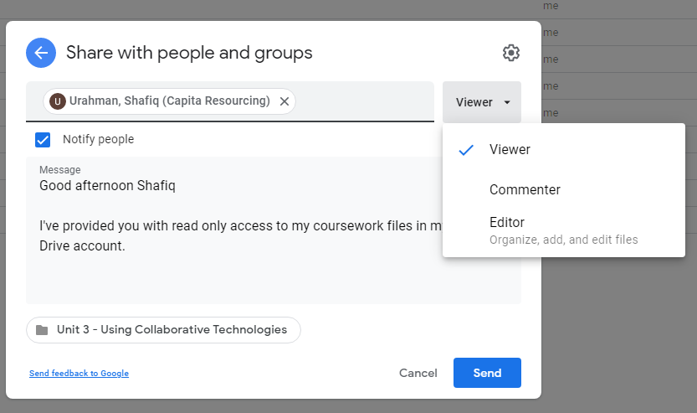

Once I select ‘Send’, I’m prompted by Google Drive that my tutor’s email address is a non-Google account and that Anyone holding this invitation will have access. In this occasion, I’m sharing my folder anyway.

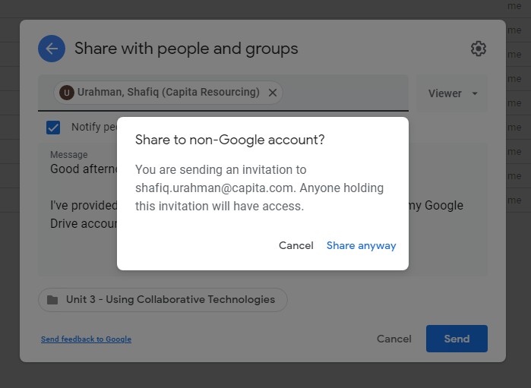

Once I select ‘Send’ and check the access again, I can now see that my tutor has access to my Unit 3 coursework via Google Drive.

